 Methods Unit 3 Test 3, 2016

(Calculator Free) Name__________________

Time: 18 minutes Marks: 18

1. [2, 1, 2, 2 marks]

Determine $\frac{dy}{dx}$ in terms of x, for the following (you do not need to simplify):

a) y =

b) y = cos2 (3x – 1)

c) y = x2. sin x.

d) y = cos 4x. cos3x + sin 4x. sin 3x

1. [2, 2, 1 marks]

Determine the following indefinite integrals:

a) $\int{2\cos{3x dx}}$

b) $\int{20 \cos^{3}x\sin{x dx}}$

c) $\int{\frac{2}{\cos^{2}x}}$ dx

1. [2, 2, 2 marks]

A discrete probability distribution for the random variable X is given below.

|  |  |  |  |  |  |
| --- | --- | --- | --- | --- | --- |
| x | 1 | 2 | 3 | 4 | 5 |
| P(X = x) | k | k + 0.3 | 0.1 | 2k | k + 0.1 |

1. Determine k.
2. Determine the mean (or expected value) of X.
3. State P(X < 4/ X > 1)



Methods Unit 3 Test 3, 2016

(Calculator Assumed) Name___________________

Time: 37 minutes Marks: 37

6. [2, 4 marks]

a) Sketch the curve y = 2 cos (0.5x) on the axes below.

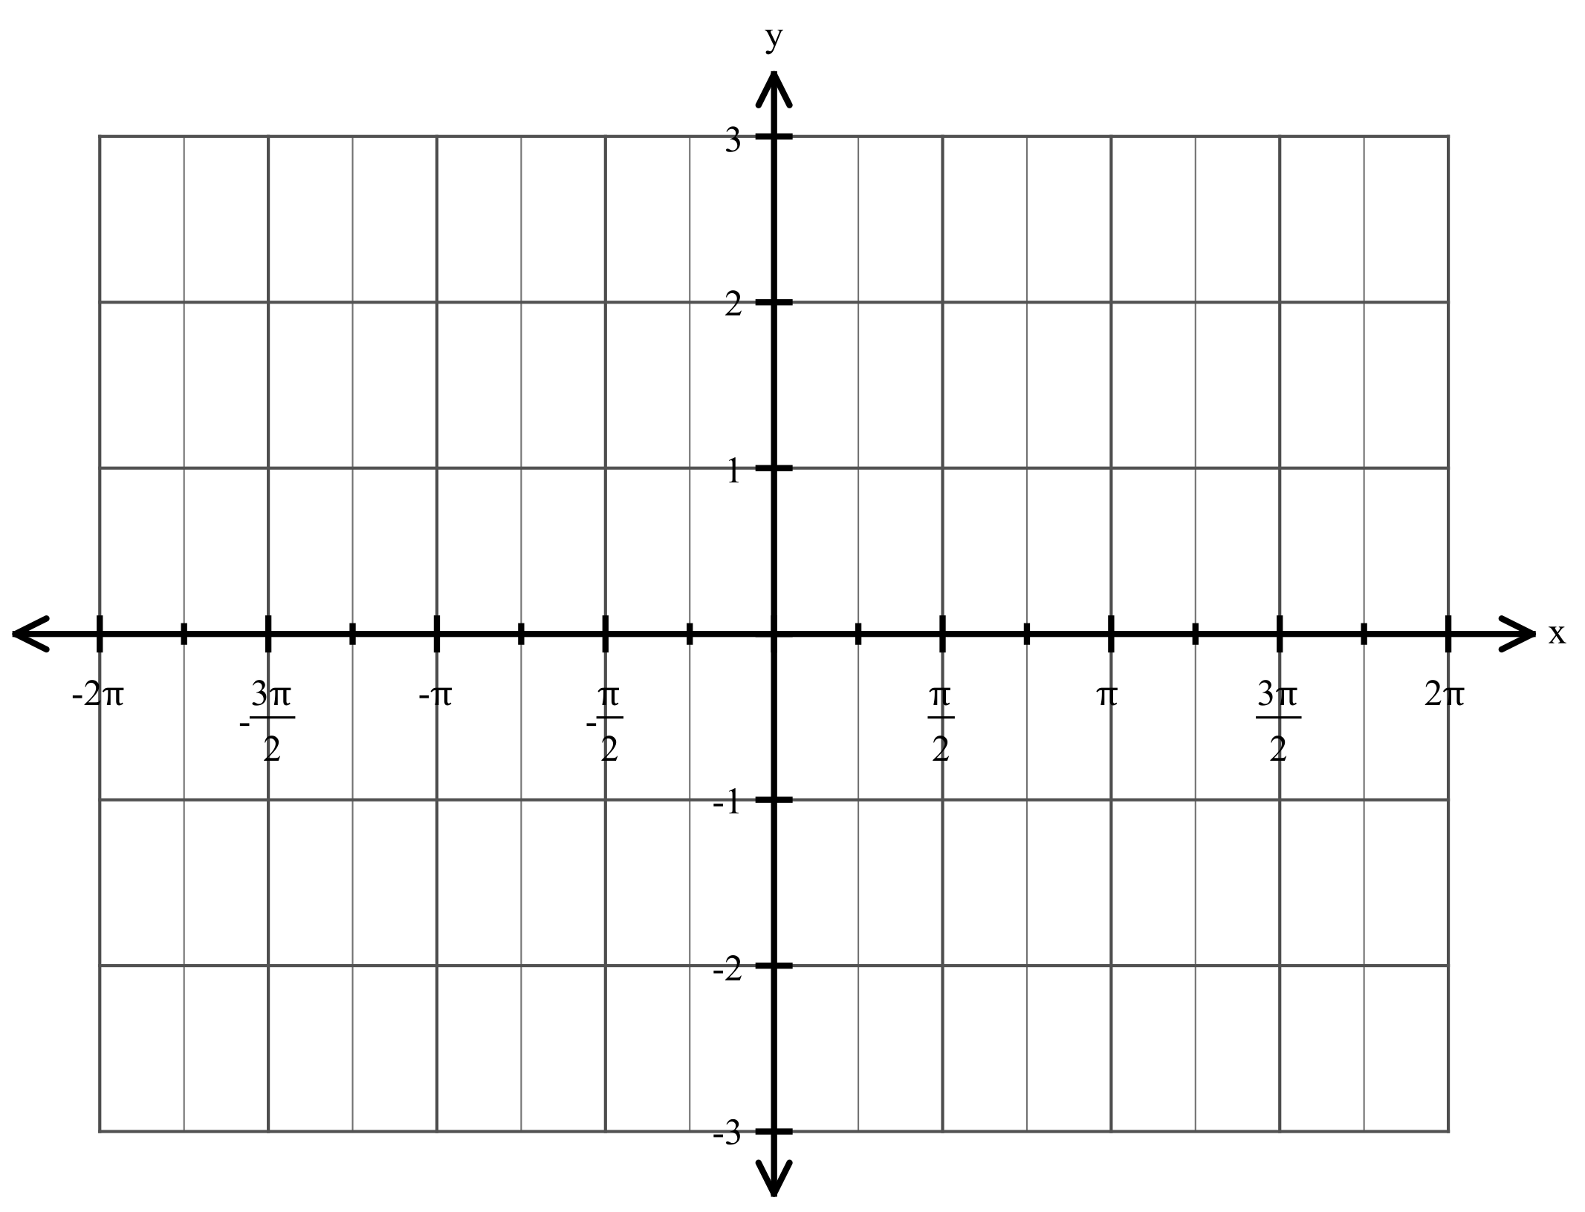

b) Determine the area between y = 2 cos (0.5x) and the x-axis for -2

7. [5 marks]

Find the equation of the tangent to the curve y = 2 sin 2x at the point where x = $\frac{π}{2}$

1. [2, 1, 1, 2, 1 marks]

The probability function for a discrete random variable is

f(x) = $\left[\begin{matrix}k\left(5-x\right) for x=1, 2, 3, 4 \\ 0 for all other values\end{matrix}\right.$

Determine k, and thus find

1. E[X]
2. E[3x - 1]
3. Var[X]
4. Var[1- 3X]

9. [1, 2, 1, 1, 2 marks]

Given that a discrete random variable is binomially distributed such that X $∼$ bin(8, 0.25), determine

1. the mean of the distribution
2. the standard deviation of the distribution
3. P(X = 2)
4. P(X $≤$ 3)
5. P (X = 3 / X < 6)

10. [1, 1, 1, 2, 3 marks]

A student who has not studied for his Biology test resorts to guessing every answer on the twenty multiple choice questions. Each question has 5 choices (where only one answer is correct).

1. Describe the probability distribution.

Determine the probability that the student has

1. at least 5 correct
2. at most 4 correct
3. 2 correct, given he has at least one correct.
4. The student realizes that he can answer 5 questions correctly. What is the probability that he can achieve at least 50% for the test (i.e. at least 10 out of 20)?

11. [4 marks]

In a Bernoulli trial, the standard deviation is 0.4

Determine E[X].